Source Data Mapping Approach to CDMV5.4

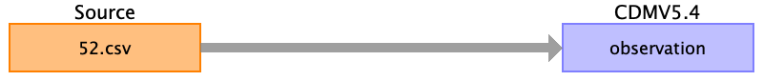

Table name: person

Table name: observation_period

Table name: visit_occurrence

Table name: visit_detail

Table name: condition_occurrence

Table name: drug_exposure

Table name: procedure_occurrence

Table name: device_exposure

Table name: measurement

Table name: observation

Reading from 52.csv

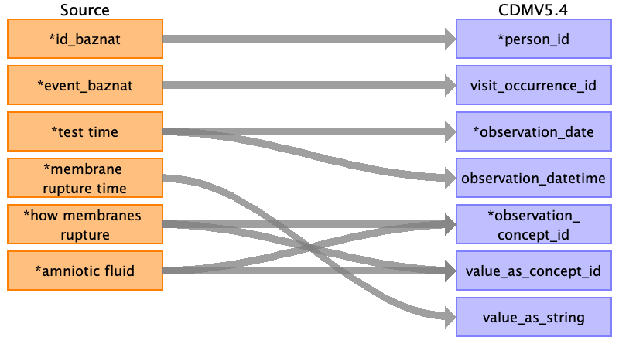

|  |  |  |  |
| --- | --- | --- | --- |
| Destination Field | Source Field | Logic | Comment |
| observation_id |  |  | ID run |
| person_id | ﻿id_baznat |  |  |
| visit_occurrence_id | event_baznat |  | Check if the value exists in the target table visit_occurrence , if not set as None |
| observation_date | test time |  | Only date DD/MM/YYYY |
| observation_datetime | test time |  | Date and time - DD/MM/YYYY HH:MM:SS |
| observation_concept_id | how membranes rupture  amniotic fluid |  | Set RUPTURED_MEMBRANES_CONCEPT_ID = 4224704  Set AMNIOTIC_FLUID_CONCEPT_ID = 40454100 |
| value_as_concept_id | how membranes rupture  amniotic fluid |  | Using an auxiliary table. |
| observation_type_concept_id |  |  | Set EHR_CONCEPT_ID = 32817 |
| value_as_number |  |  | Not use in this field. |
| value_as_string | membrane rupture time |  | Value from source table. |
| qualifier_concept_id |  |  |  |
| unit_concept_id |  |  | According to visit_detail_id |
| provider_id |  |  | Not use in this field. |
| visit_detail_id |  |  | According to visit_occuerrence id and time. |
| observation_source_value |  |  | Not use in this field. |
| observation_source_concept_id |  |  | Not use in this field. |
| unit_source_value |  |  | Not use in this field. |
| qualifier_source_value |  |  | Not use in this field. |
| value_source_value |  |  | Not use in this field. |
| observation_event_id |  |  | Not use in this field. |
| obs_event_field_concept_id |  |  | Not use in this field. |

Table name: death

Table name: note

Table name: note_nlp

Table name: specimen

Table name: fact_relationship

Table name: location

Table name: care_site

Table name: provider

Table name: payer_plan_period

Table name: cost

Table name: drug_era

Table name: dose_era

Table name: condition_era

Table name: episode

Table name: episode_event

Table name: metadata

Table name: cdm_source

Table name: cohort

Table name: cohort_definition

Appendix: source tables

Table: 52.csv

|  |  |  |  |
| --- | --- | --- | --- |
| Field | Type | Most freq. value | Comment |
| ﻿id_baznat | INT |  |  |
| event_baznat | INT |  |  |
| test time | INT |  |  |
| unit | INT |  |  |
| membrane rupture time | INT |  |  |
| how membranes rupture | INT |  |  |
| amniotic fluid | INT |  |  |
| record_date | INT |  |  |